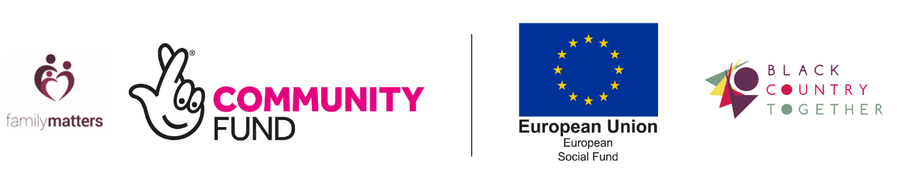

**Family Matters Progression Officer**

**Job Description and Person Specification**

**Salary:** £23,541 pro rata

**Hours:** 18.5 per week – working pattern to be discussed

**Location:** Dudley/Remote with travel across all areas of the Black Country.

**Job Type:** Fixed term until September 2022

**Category**: Admin

**Sectors:** Social Welfare

**We are recruiting a Progression Officer to work with the Family Matters partnership, delivering holistic support to families across the Black Country.**

**Black Country Together CIC**

Black Country Together CIC was founded in 2013 by the four Councils for Voluntary Service in the Black Country with the aim of increasing levels of funding coming into the sub-region. We believe that locally-designed, locally-delivered solutions to social challenges offer the best outcomes for communities and the best value for funders.

We are a young and vibrant organisation with a strong track record of success, which this role will contribute towards. Family Matters is one of the 3 projects making up Building Better Opportunities in the Black Country, funded by the European Social Fund and the National Lottery Community Fund. It represents a huge opportunity for the Black Country, and our 8 strong partnership delivery team work with Black Country people and their families to develop a journey that is right for them and can move them closer to the mainstream labour market.

**About the Role**

We are looking for a Progression officer to join our small Programme Management Team. The ideal candidate will have experience of ESF/ERDF/DWP and will be comfortable ensuring compliance with the funder’s requirements. To support our partnership delivery team with the progression of participant journeys and to support the Partnership Manager and Compliance Officers to provide effective programme reporting to the Directors and the programme funders.

**Applying for the role**

For further information on how to apply interested parties should visit: <https://blackcountrytogether.info/building-better-opportunities/>

or alternatively contact Partnership Manager Hannah Clarke on 07969 277991 or Hannah@Blackcountrytogether.info

Black Country Together is an equal opportunities employer and welcomes applications from all sections of the community.

Applications should be submitted by: 11.59pm Friday 11th June 2021. Late applications will not be accepted. Interview date TBC.